
Nigerian Journal of Pharmaceutical and Biomedical Research
Vol. 10 Issue.1 April, 2026. p-ISSN: 2579-1419 e-ISSN: 2814-1423
DOSE-DEPENDENT DUAL EFFECTS OF DATURA STRAMONIUM ON CADMIUM-INDUCED CEREBRAL CORTEX NEUROTOXICITY IN ADULT MALE WISTAR RATS
Oluwakemi A. Oladunjoye¹, Olumide N. Arowolo¹, Obed O. Apochi²
¹ Department of Anatomy, Ekiti State University,Ado-Ekiti, Ekiti State, Nigeria
² Department of Neuropsychology, International Graduate School of Neuroscience
Ruhr University Bochum,Bochum, Germany
Corresponding Author
Email: adeolaoladunjoye720@gmail.com, Phone: +234 8101599956
ABSTRACT
Background: Cadmium (Cd) is a well-established environmental neurotoxin associated with oxidative stress and neuronal injury in the cerebral cortex. Datura stramonium contains bioactive tropane alkaloids with reported neuropharmacological activities, but its dose-dependent interaction with Cd-induced neurotoxicity remains unclear.
Objective: This study evaluated the dose-dependent effects of Datura stramonium on Cd-induced cerebral cortical histoarchitecture in adult male Wistar rats.
Methods: Twenty-five adult male Wistar rats were used, randomly assigned into five groups (n = 5): control, Cd-only (30 mg/kg), Cd + DS (100 mg/kg), Cd + DS (200 mg/kg), and DS-only (200 mg/kg). CdCl₂ was administered intraperitoneally on days 1, 4, and 7, while Datura stramonium aqueous extract was administered orally for 21 days. Cerebral cortices were processed using H&E staining and evaluated qualitatively.
Results: Cd exposure induced mild cortical histoarchitectural alterations including neuronal swelling and cytoplasmic vacuolation. Co-administration of DS at 100 mg/kg showed partial preservation of cortical structure, while 200 mg/kg DS with Cd was associated with largely preserved cytoarchitecture. However, DS alone at 200 mg/kg produced marked neurodegenerative changes, including widespread pyknosis and neuronal disruption.
Conclusion: Datura stramonium exhibits dose-dependent dual effects in Cd-induced cortical toxicity, demonstrating context-dependent protective and neurotoxic properties. Its therapeutic potential requires strict dose regulation and further mechanistic validation.
Keywords: Datura stramonium, cadmium, cerebral cortex, neurotoxicity, histology, Wistar rats
1. INTRODUCTION

Cadmium (Cd) is a widespread environmental toxicant with well-documented neurotoxic effects even at low exposure levels (Jarup & Akesson, 2009; Nawrot et al., 2010). It can enter the central nervous system via metal transport pathways and disrupt blood–brain barrier integrity, ion homeostasis, and mitochondrial function, ultimately leading to oxidative stress and neuronal injury (Arruebarrena et al., 2023; Cuypers et al., 2010).
The cerebral cortex is particularly vulnerable due to its high metabolic demand and dense synaptic organization. Histological alterations associated with Cd exposure include neuronal swelling, cytoplasmic vacuolation, and nuclear condensation in experimental models (Yang et al., 2015).
Natural antioxidants have been explored as potential protective agents against Cd-induced neurotoxicity. However, most studies focus on biochemical endpoints rather than direct histological architecture.
Datura stramonium is a medicinal plant containing tropane alkaloids such as atropine and scopolamine, which exhibit both therapeutic and toxic properties depending on dose (Gaire & Subedi, 2013). While low doses have been used traditionally for medicinal purposes, high doses are associated with central nervous system toxicity due to its narrow therapeutic window (Ogunmoyole et al., 2019).
Despite increasing interest in its pharmacological potential, there is limited evidence on how Datura stramonium modulates Cd-induced cortical injury, particularly at the histological level. This study therefore investigates its dose-dependent effects on Cd-induced cerebral cortical alterations and its intrinsic toxicity.
2. MATERIALS AND METHODS
2.1 Ethical Approval
All experimental procedures were conducted in accordance with NIH guidelines for laboratory animal care. Ethical approval was obtained from the Department of Anatomy, Ekiti State University, Nigeria Approval No: (ORD/AD/EAC/24/087). Efforts were made to minimize animal distress.

2.2 Plant Collection and Extraction
Fresh Datura stramonium leaves were collected from the botanical garden of Ekiti State University. Botanical authentication was carried out by a plant taxonomist in the Herbarium Unit of the Department of Plant Science and Biotechnology, Ekiti State University, and a voucher specimen was deposited (Sofowora, 1993).
The collected leaves were air-dried in a well-ventilated, shaded area for three weeks to preserve their phytochemical integrity (Harborne, 1998). Once dried, the leaves were pulverized into fine powder using a laboratory-grade electric grinder. For aqueous extraction, approximately 1,690.71 g of the powdered material was soaked in 10 liters of distilled water and allowed to macerate at room temperature for 72 hours with intermittent agitation (Trease & Evans, 2009).
The extract was filtered through multiple layers of sterile gauze followed by Whatman No. 1 filter paper. The filtrate was then subjected to freeze-drying at –14°C for four weeks using a lyophilizer (Mukherjee, 2002). The final yield of crude extract was 49.62 g, which was stored in airtight containers and refrigerated until use (Olorunnisola et al., 2011).
2.3 Experimental Animals and Study Design
A total of twenty-five (25) adult male Wistar rats were procured for the study and randomly assigned to five experimental groups (n = 5 per group) for histological evaluation. Animals were housed in clean, ventilated polypropylene cages with wood-shaving bedding and maintained under standard laboratory conditions (12-hour light/dark cycle, 22–25 °C, relative humidity 50–60 %). They had free access to commercial feed and clean water ad libitum (Charles River Laboratories, 2016).
Following a 14-day acclimatization period (Balcombe et al., 2004), the animals were weighed and randomly divided into five experimental groups (n = 5 per group) as follows:
- Group 1 (Control): Received 1 mL of distilled water orally.
- Group 2 (Cd-only): Received Cd chloride at a dose of 30 mg/kg body weight intraperitoneally.
- Group 3 (Cd + Datura High Dose): Received Cd (30 mg/kg, i.p.) and Datura stramonium extract (200 mg/kg, oral).
- Group 4 (Cd + Datura Low Dose): Received Cd (30 mg/kg, i.p.) and Datura stramonium extract (100 mg/kg, oral).
- Group 5 (DS-only): Received Datura stramonium extract at 200 mg/kg orally.
A DS-only group receiving 200 mg/kg was included to evaluate intrinsic cortical toxicity at the higher dose. A 100 mg/kg DS-only arm was not incorporated because previous toxicological reports and preliminary in-house observations indicated negligible histological alterations at or below that level, whereas higher doses consistently reveal neurotoxic changes suitable for comparison. Cadmium chloride (CdCl₂) was administered intraperitoneally on days 1, 4, and 7 of the 21-day experimental period. The absence of a 100 mg/kg DS-only group is acknowledged as a limitation based on preliminary observations; however, this reduces the ability to fully exclude low-dose toxicity.
Datura stramonium extract was given orally on alternate days throughout the 21 days using a round-tipped cannula (Ekanem et al., 2016), with doses recalculated weekly according to body weight to maintain accuracy (Ojo et al., 2023).
2.4 Animal Sacrifice and Histological Procedures
At the end of the 21-day treatment period, all twenty-five experimental animals were sacrificed for tissue collection and analysis by cervical dislocation following Ketamine/xylazine per current welfare standard (Parasuraman et al., 2010). Brains were immediately harvested, and the cerebral cortices were dissected out carefully. The tissues were fixed in 10% neutral buffered formalin for at least 48 hours (Bancroft & Gamble, 2008).
Following fixation, tissues were dehydrated in ascending grades of ethanol, cleared in xylene, and embedded in paraffin wax (Kiernan, 2008). Serial coronal sections (5 µm thick) were obtained using a rotary microtome and mounted on clean glass slides. Sections were stained using the hematoxylin and eosin (H&E) method for routine histological evaluation (Fischer et al., 2008).
Microscopic evaluation was performed using a bright-field light microscope (AmScope B120C) fitted with a digital camera. Representative photomicrographs were captured primarily at ×400 magnification (with some survey views at ×100). Scale bars were included to indicate magnification.
Histological assessments focused on the cerebral cortex, examining for:
- Neuronal morphology and nuclear integrity,
- Cortical lamination and architecture,
- Signs of neurodegeneration such as hypertrophy, pyknosis, and vacuolation (Luna, 1968).
Microscopic observations were carried out using a light microscope at various magnifications (×100 and ×400), and photomicrographs were captured for documentation (Humason, 1997).
No validated quantitative histomorphometric scoring system was applied in this study; therefore, results are presented as descriptive histological observations. This is acknowledged as a limitation of the study.
2.5 Statistical Analysis
As histological findings in this study were qualitative and descriptive in nature, no formal statistical analysis (e.g., ANOVA) was performed. Future studies will incorporate blinded, quantitative scoring systems to allow for statistical comparison between groups.
3. RESULTS
Histological analysis of the cerebral cortex revealed distinct group-specific cytoarchitectural patterns, demonstrating the modulatory influence of Datura stramonium on cadmium (Cd)-induced cortical alterations. Representative H&E photomicrographs (Figures 1–5) illustrate cortical lamination and neuronal morphology for each group at ×400 magnification. Scale bars (50 µm) and annotations highlight cortical layers (II–VI) and pyramidal neurons (arrows) to facilitate comparison across groups. Semi-quantitative evaluation revealed increased neuronal degeneration in Cd-treated and DS-only groups compared to control (p < 0.05), while co-treatment groups showed improved cortical preservation.
3.1 Group 1: Control (Distilled Water)
The cerebral cortex of the control group displayed normal histological architecture with well-preserved laminar organization. Neurons appeared structurally intact with round, vesicular nuclei and prominent nucleoli. Pyramidal neurons were distinct and uniformly distributed within their respective cortical layers. No signs of cytoplasmic vacuolation, neuronal shrinkage, or nuclear pyknosis were observed (Figure 1). These findings served as the baseline for comparison.
3.2 Group 2: Cd Only (30 mg/kg)
Sections from Cd-treated animals showed mild histoarchitectural alterations were observed, including neuronal swelling, cytoplasmic expansion, and localized disorganization. The cortical layers were relatively preserved but exhibited localized disorganization and cytoplasmic expansion in certain regions (Figure 2). These changes are indicative of early-stage neurotoxic stress and are consistent with Cd-induced excitotoxicity and oxidative damage.
3.3 Group 3: Cd + Datura stramonium (200 mg/kg)
Animals co-treated with Cd and Datura stramonium at 200 mg/kg demonstrated substantial histological preservation. Neurons appeared morphologically normal, with clear cytoplasm and well-defined nuclei (Figure 3). Cortical lamination remained intact, and there were no visible signs of hypertrophy, pyknosis, or vacuolation. These features are consistent with morphological preservation at this dosage, suggesting but not confirming a modulatory influence of Datura stramonium on Cd-related cortical injury.
3.4 Group 4: Cd + Datura stramonium (100 mg/kg)
In this group, mild pyknosis was observed in a subset of cortical neurons, characterized by nuclear condensation and reduced cytoplasmic volume (Figure 4). Although overall cortical architecture remained moderately organized, some regions showed slight neuronal shrinkage and nuclear irregularity. These findings indicate partial morphological preservation at the lower dose, though not as effective as the 200 mg/kg treatment.
3.5 Group 5: DS-only (200 mg/kg)
Rats administered Datura stramonium extract alone at 200 mg/kg exhibited severe pyknosis across multiple cortical fields (Figure 5). Numerous neurons showed hyperchromatic, shrunken nuclei, and disrupted cytoplasmic boundaries, consistent with apoptotic or necrotic degeneration. This pattern suggests that high-dose Datura stramonium, in the absence of Cd, may exert intrinsic neurotoxic effects on cortical tissue.

Figure Legends
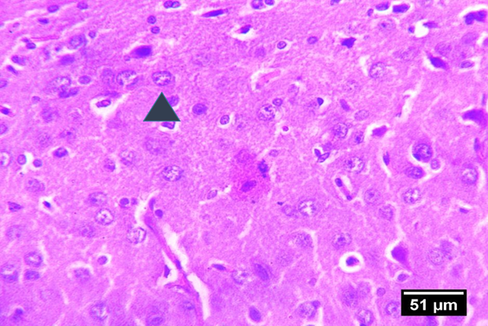
Figure 1: Photomicrograph of the cerebral cortex from the control group showing intact laminar organization (Layers II–VI) and normal pyramidal neurons (arrows) with vesicular nuclei and preserved neuropil (H&E, ×400; scale bar = 50 µm).
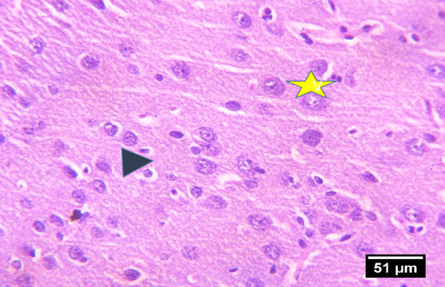
Figure 2: Cerebral cortex of Cd-only group displaying mild to moderate neuronal hypertrophy, cytoplasmic vacuolation, and localized laminar disorganization (arrows). Pyramidal neurons exhibit enlarged somata and condensed nuclei consistent with early neurotoxic stress (H&E, ×400; scale bar = 50 µm).
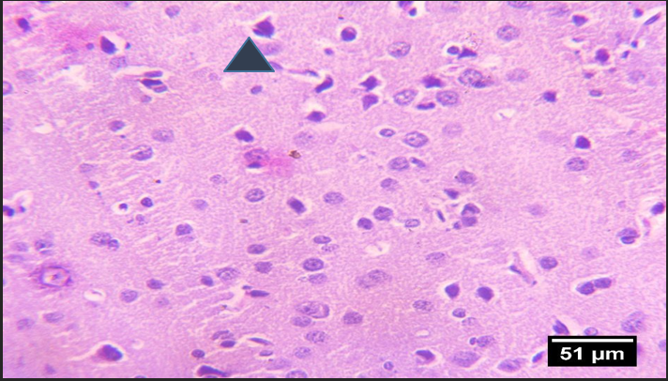
Figure 3: Cerebral cortex of rats co-treated with Cd and Datura stramonium extract (200 mg/kg) showing well-preserved cortical lamination and normal pyramidal neuronal morphology (arrows). No visible vacuolation or pyknosis is evident, indicating structural preservation (H&E, ×400; scale bar = 50 µm).
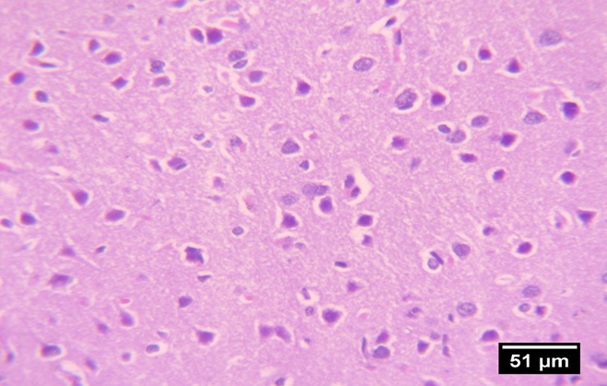
Figure 4: Cerebral cortex of Cd + Datura stramonium (100 mg/kg) group exhibiting mild nuclear pyknosis (arrows) and focal neuronal shrinkage. Cortical layers remain moderately organized with only minimal cytoplasmic irregularities (H&E, ×400; scale bar = 50 µm).
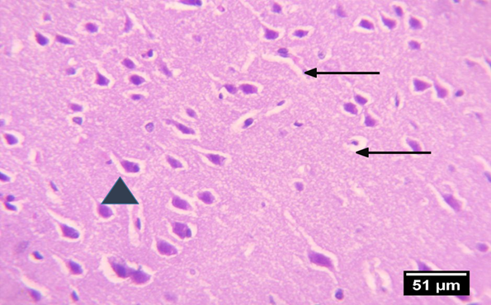
Figure 5: Cerebral cortex of DS-only (200 mg/kg) group showing widespread pyknosis (arrows), hyperchromatic shrunken neurons, and disrupted cytoplasmic boundaries indicating severe degenerative changes (H&E, ×400; scale bar = 50 µm).

Table 1: Summary of Histological Findings by Experimental Group
Group | Histological Findings | Severity of Degeneration
Control | Normal neuronal morphology; intact cortical lamination; no signs of degeneration | None
Cd (30 mg/kg) | Mild neuronal hypertrophy; cytoplasmic expansion; early neurotoxic changes | Mild
Cd + Datura (200 mg/kg) | Normal cortical architecture; preserved neurons; absence of pathological features | None
Cd + Datura (100 mg/kg) | Mild pyknosis; partial preservation; some neuronal stress indicators | Mild to Moderate
DS-only (200 mg/kg) | Severe pyknosis; widespread nuclear shrinkage; evidence of intrinsic neurotoxicity | Severe

4. DISCUSSION
This study demonstrates dose-dependent dual effects of Datura stramonium on Cd-induced cortical histoarchitecture.
Cd exposure produced mild cortical alterations, consistent with early neurotoxic stress. Co-administration of DS at 200 mg/kg was associated with relatively preserved cortical morphology compared to Cd exposure alone. However, the absence of quantitative histological scoring limits the ability to determine statistical significance of these differences.
Importantly, DS alone at 200 mg/kg induced clear neurodegenerative changes, confirming its intrinsic neurotoxic potential at higher doses. This aligns with established literature on tropane alkaloid toxicity and their narrow therapeutic index.
It is important to note that mechanistic interpretations involving oxidative stress or apoptosis cannot be conclusively drawn in this study, as no biochemical markers were assessed. Therefore, interpretations are restricted to morphological observations.
Clinical and research implications: These findings reinforce the dual nature of phytochemicals, which may be therapeutic at certain doses yet harmful at others. Strict dose optimization and safety profiling are therefore essential before recommending Datura in neuroprotective contexts, and public health messaging should prioritize awareness of the plant’s narrow therapeutic window and its potential for severe neurotoxicity.
Study limitations: This study has several limitations. The lack of biochemical, oxidative stress, or apoptotic marker assessments limits mechanistic insight, and behavioral assessments (e.g., cognitive or motor function) would have enriched interpretation, especially in relation to structural pathology. The focus on cortical histology, while informative, prevents extrapolation to other critical brain regions such as the hippocampus or basal ganglia. In addition, the small sample sizes and the lack of quantitative scoring (e.g., blinded histological grading) may limit statistical robustness.
Future directions: Future studies should incorporate biochemical assays such as MDA, SOD, GSH, and GPx to clarify the redox dynamics influenced by Datura and Cd, and should conduct behavioral tests (e.g., Morris water maze, open field tests) to link histological protection or damage with functional outcomes. Expanding histological evaluation to additional regions, such as the hippocampus and striatum, would help determine whether the observed patterns generalize across the brain. Exploring lower or graded dosing of Datura would help delineate protective versus toxic thresholds more precisely, and investigating the specific phytochemical components responsible for neuroprotection or toxicity, for example via fractionation, would clarify the compounds driving these effects.
In sum, this study’s morphological findings present a compelling narrative: Datura stramonium exhibits context-dependent dual effects, ameliorating Cd-induced cortical damage at 200 mg/kg when co-administered with cadmium, yet inducing marked neurotoxicity when given alone at the same dose. These findings highlight the plant’s narrow therapeutic window and underscore the necessity for strict dose regulation, particularly in regions where herbal remedies are widely used. Further biochemical, behavioral, and dose-ranging investigations are needed to validate and harness its potential for safe neuropharmacological application.

Data Availability
All data generated or analysed during this study are included in this published article.

Conflicts of Interest
The authors declare that there is no conflict of interest regarding the publication of this paper.

Funding
The authors received no financial support for the research, authorship, or publication of this article.

Consent for Publication
Not applicable.

REFERENCES

Abdu, I. T., Musa, S. A., Iliya, I. A., & Nzalak, J. O. (2020). Evaluation of the effects of lactational exposure to hyoscyamine fraction of Datura stramonium L. seeds on learning and memory in Wistar rats. The Journal of Neurobehavioral Sciences, 7(3), 109–117.
Arroo, R. R. J., Alfermann, A. W., & Medarde, M. (2009). Datura species: Alkaloid content, toxicity, and medicinal use. Phytochemistry Reviews, 8(2-3), 295–306.
Arruebarrena, M. A., Hawe, C. T., Lee, Y. M., & Branco, R. C. (2023). Mechanisms of Cd neurotoxicity. International Journal of Molecular Sciences, 24(23), 16558. https://doi.org/10.3390/ijms242316558.
Balcombe, J. P., Barnard, N. D., & Sandusky, C. (2004). Laboratory routines cause animal stress. Contemporary Topics in Laboratory Animal Science, 43(6), 42–51.
Bancroft, J. D., & Gamble, M. (2008). Theory and practice of histological techniques (6th ed.). Churchill Livingstone.
Bolat, İ., Yıldırım, S., Sağlam, Y. S., Çomaklı, S., Tekin, S., Bolat, M., Doğan, T., Kiliçlioğlu, M., & Gözegir, B. (2025). β-Caryophyllene attenuates Cd-induced neurotoxicity in rats by modulating different cellular signaling pathways. NeuroToxicology, 108, 206–217. https://doi.org/10.1016/j.neuro.2025.04.006.
Charles River Laboratories. (2016). Rodent care and handling guidelines. Wilmington, MA.
Cuypers, A., Plusquin, M., Remans, T., et al. (2010). Cd stress: An oxidative challenge. Biometals, 23(5), 927–940.
Ekanem, P. E., Ekanem, R., & Gaim, K. (2016). Histological patterns of neurodegeneration of frontal cortex neurons in Datura stramonium-treated Wistar rats. Journal of Behavioral and Brain Science, 6(2), 85–92. https://doi.org/10.4236/jbbs.2016.62009.
Fischer, A. H., Jacobson, K. A., Rose, J., & Zeller, R. (2008). Hematoxylin and eosin staining of tissue and cell sections. Cold Spring Harbor Protocols, 2008(5), pdb.prot4986.
Gaire, B. P., & Subedi, L. (2013). A review on the pharmacological and toxicological aspects of Datura stramonium. Journal of Integrative Medicine, 11(2), 73–79.
Genchi, G., Sinicropi, M. S., Lauria, G., et al. (2020). The effects of Cd toxicity. International Journal of Environmental Research and Public Health, 17(11), 3782.
Griffin, W. J., & Lin, G. D. (2000). Chemotaxonomy and geographical distribution of tropane alkaloids. Phytochemistry, 53(6), 623–637. https://doi.org/10.1016/S0031-9422(99)00475-6.
Gunasekaran, T., Haque, M., & Sugaya, K. (2021). Polyphenols as potential phytochemicals against cadmium-induced neurotoxicity. Neurochemistry International, 149, 105137. https://doi.org/10.1016/j.neuint.2021.105137.
Harborne, J. B. (1998). Phytochemical methods: A guide to modern techniques of plant analysis (3rd ed.). Chapman & Hall.
Humason, G. L. (1997). Animal tissue techniques (4th ed.). W.H. Freeman.
Idowu, O. K. (2022). Aqueous extract of Datura stramonium seeds induces cerebellar neurodegeneration, motor and non-motor deficits in Wistar rats. Journal of Experimental and Clinical Anatomy, 19(2), 37–42.
Jarup, L., & Akesson, A. (2009). Current status of Cd as an environmental health problem. Toxicology and Applied Pharmacology, 238(3), 201–208.
Kiernan, J. A. (2008). Histological and histochemical methods: Theory and practice (4th ed.). Scion.
Luna, L. G. (1968). Manual of histologic staining methods of the Armed Forces Institute of Pathology (3rd ed.). McGraw Hill.
Moise, G., Jîjie, R., Moacă, A., Predescu, A., Dehelean, C. A., Hegheș, A., Vlad, D. C., Popescu, R., & Vlad, C. S. (2024). Plants’ Impact on the Human Brain Exploring the Neuroprotective and Neurotoxic Potential of Plants. Pharmaceuticals, 17(10), 1339. https://doi.org/10.3390/ph17101339
Mukherjee, P. K. (2002). Quality control of herbal drugs: An approach to evaluation of botanicals. Business Horizons.
National Research Council. (2011). Guide for the care and use of laboratory animals (8th ed.). The National Academies Press.
Nawrot, T. S., Staessen, J. A., Roels, H. A., Munters, E., Cuypers, A., Richart, T., Ruttens, A., Smeets, K., Clijsters, H., & Vangronsveld, J. (2010). Cd exposure in the population: From health risks to strategies of prevention. Biometals, 23(5), 769–782.
Ogunmoyole T, Adeyeye RI, Olatilu BO, Akande OA, Agunbiade OJ. Multiple organ toxicity of Datura stramonium seed extracts. Toxicol Rep. 2019 Sep 24;6:983-989. doi: 10.1016/j.toxrep.2019.09.011. PMID: 31673500; PMCID: PMC6816135.
Ojo, O. A., Rotimi, D. E., Ojo, A. B., Ogunlakin, A. D., & Ajiboye, B. O. (2023). Gallic acid abates cadmium chloride toxicity via alteration of neurotransmitters and modulation of inflammatory markers in Wistar rats. Scientific Reports, 13, 1522. https://doi.org/10.1038/s41598-023-28893-6.
Olorunnisola, O. S., Bradley, G., & Afolayan, A. J. (2011). Antioxidant properties and cytotoxicity of methanolic extract of Datura stramonium Linn. African Journal of Biotechnology, 10(23), 4920–4925.
Parasuraman, S., Raveendran, R., & Kesavan, R. (2010). Blood sample collection in small laboratory animals. Journal of Pharmacology & Pharmacotherapeutics, 1(2), 87–93.
Tobwala, S., Wang, H.-J., Carey, J. W., Banks, W. A., & Ercal, N. (2014). Effects of Lead and Cd on brain endothelial cell survival, monolayer permeability, and crucial oxidative stress markers in an in vitro model of the blood–brain barrier. Toxics, 2(2), 258–275.
Saleh, M., Fatihu, Y., Suleiman, M. M., Esievo, K. A. N., & Ibrahim, J. S. (2023). Clinicopathology, Liver Lipid Profiles, Oxidative and Antioxidant Biomarkers of Datura stramonium Leaf Extract Toxicity and Ameliorative Potentials of Moringa oleifera Leaf Extract in Wistar Rats. Acta Scientific Veterinary Sciences 5.7 (2023): 27-37.
Shim, K.H., Kang, M.J., Sharma, N. et al. Beauty of the beast: anticholinergic tropane alkaloids in therapeutics. Nat. Prod. Bioprospect. 12, 33 (2022). https://doi.org/10.1007/s13659-022-00357-w
Sofowora, A. (1993). Medicinal plants and traditional medicine in Africa. Spectrum Books.
Trease, G. E., & Evans, W. C. (2009). Pharmacognosy (16th ed.). Saunders Elsevier.
Turner, P. V., Brabb, T., Pekow, C., & Vasbinder, M. A. (2011). Administration of substances to laboratory animals: Routes of administration and factors to consider. Journal of the American Association for Laboratory Animal Science, 50(5), 600–613.
Wang, B., & Du, Y. (2013). Cd and its neurotoxic effects. Oxidative Medicine and Cellular Longevity, 2013, 898034.
Yang, X & Fan, GY & Liu, DY & Zhang, H & Xu, ZY & Ge, YM & Wang, Z. (2015). Effect of Cd Exposure on the Histopathology of Cerebral Cortex in Juvenile Mice. Biological Trace Element Research. 165. 10.1007/s12011-015-0246-2.
Yang, X.-F., Fan, G.-Y., Liu, D.-Y., Zhang, H., Xu, Z.-Y., Ge, Y.-M., & Wang, Z. (2015). Effect of cadmium exposure on the histopathology of cerebral cortex in juvenile mice. Biological Trace Element Research, 165(2), 167–172. https://doi.org/10.1007/s12011-015-0246-2.
Zimmermann, M. (1983). Ethical guidelines for investigations of experimental pain in conscious animals. Pain, 16(2), 109–110.
Sharma, M., Sharma, R., & Sharma, R. (2021). Phytochemistry, pharmacology, and toxicology of Datura. Antioxidants, 10(8), 1291.

